XuZhou Placements

Guide written by Victoria Miller, teacher in Xuzhou (2015-2016)

Working for in Xuzhou will give you a comfortable way in moving to China. Because it is a relatively small school, you can feel assured that if you have any issues, questions or need any assistance the couple in charge, Meiting and Morgan will be more than happy to assist you. Moving to China is daunting, especially not speaking the language and if things stop working or you need to try and pay bills, other teaching companies tend to just expect you to sort these problems yourself. They assist you in all of this and also try and do it as quickly as possible.

Hours
Under my contract I work a 24 hour week with 6 hours preparation time (total of 30 hours). These are actually 24 classes at 40 minutes each, however due to various breaks (10 minutes – 25 minutes) each class counts towards an “hour”.

If I work more than a 24 hour week they will pay me £10 per extra hour.

I know a few employees that in their second term opted to work in Kindergarten. These employees work slightly fuller days, however can get paid up to £700 per month instead of the £580 that I get paid.

Teaching Materials Provided
Upon arriving I was pleasantly surprised to find that we were the first ‘batch’ of long term teachers that have been supported with lesson plans. This is something that I am aware took up a huge amount of previous teacher’s time. I think that the school wishes to provide a consistent and high standard method of teaching to their clients and therefore this is a positive move for both them and us as teachers.

This does not mean that I do not spend around the 6 hours listed planning my lessons the night before, I use the lesson plan to guide myself through the lesson however tend to add a few games or different ideas around the topic to engage the children well and to ensure I am teaching for the specific class’s capability (as even though the class may be the same age, some schools are slightly more advanced than others).

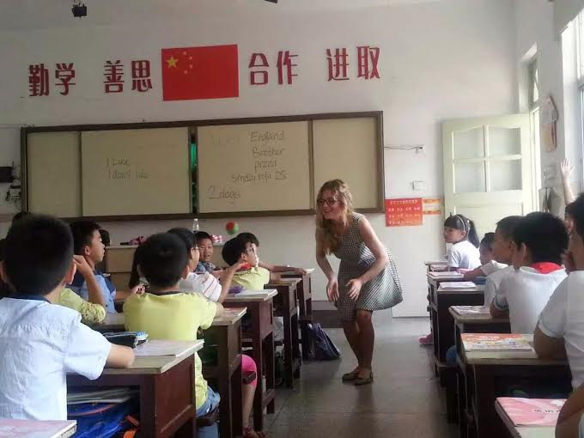

Housing
The housing here is quite basic. Although we have been provided with double beds and a fairly roomy flat, I have missed having a bath and a shower that doesn’t actually soak the floor that the toilet is in! In my flat we got around these issues by actually ensuring that we cleaned areas of it on a weekly or two weekly basis. Therefore even if certain parts of our flat were quite basic, they never get too dirty and therefore you don’t necessarily feel so bad about this!

The point I do want to make is that the rent itself is extremely cheap; I pay 500 RMB per month (around £50). The living situation is something that Meiting (the boss) has always said if we want to live somewhere else we can; she provided us with accommodation as that is what we asked for, however if we wish to look and find our own flat to rent (whether it be better quality for more money per month) that is something which she has said she can help us with.

As someone who is actually quite fussy I wish to add at this point it really isn’t that bad! I would personally say my half of residence in Edinburgh were worse!

Transport in XuZhou
XuZhou is very much a developing city. We currently walk or get buses to all of our schools. The buses are very reliable and frequent. However the city is undergoing construction and will have a subway (apparently 2016), where this will go to and from I am unsure but I know the construction goes from one side of the city through the city centre to the other side.

The city is really not that difficult to get around (although it may seem daunting at the beginning) and even after a month you begin to recognise and differentiate between the strangest of areas and even tiny shops that at the beginning all look identical!

The first two weeks of teaching a (Chinese) English teacher from the school will accompany you by bus or foot to your classes, therefore allowing you to focus primarily on your teaching for those nerve racking first few lessons, as well as providing a stress-free way of learning your timetable and how to get to your school.

Best way to explore China from XuZhou
XuZhou is in Jiangsu province, which has short train journeys every ten minutes to the famous city of Nanjing. The city is also on the high-speed train line almost exactly half way between Bei Jing and Shanghai, making both easily accessible in around 3 hours (one way tickets costing around £35-45).

XuZhou also has a small airport allowing for quick flights to various southern parts of China and Hong Kong.

If you wish to travel cheaply in China the trains are a very reliable means of transport. There are many types of trains and different “class” tickets that can be purchased to all over China. I have personally enjoyed all of the train journeys I have been on in China (APART FROM a train called the D train, where I was given a bed instead of a seat to share with around three or four people at once- however serves me right for choosing the cheapest train option).

Packing Tips
As a girl, I would recommend bringing a long supply of products such as shampoo, conditioner and your favorite face wash etc, all of these are available to you here at around the same price, however in most shops the best hair care and only one you are likely to recognise is Pantene.

One thing I would definitely recommend stocking up on is spray deodorant. It is basically not even a concept here. There is a chain of shops in this city called Watsons that sell a few cans at around £4 a bottle (the price of around 3 meals here!!!).

Ensure you bring clothes for both summer and winter. It does get cold here!! I would not recommend bringing your best shoes or clothes but do bring casual- smart clothing for teaching. Shoes wise, ones that you can wear in the summer and ones that can be worn in the winter are fine. I have brought an old pair of boots as some of the streets are quite dirty and dusty so I felt there was no point in wearing my best or smartest shoes. So long as you look presentable and like you mean to do your job properly, Meiting does not mind about the dress code too much, fairly smart looking trainers, jeans and a smart top or shirt are okay.

If you feel you will get homesick BRING your home comforts!! Bring a packet of your favorite chocolate, or your favorite movie on DVD. Until I mastered how to watch English TV in China I was very happy that I had brought a few movies with me.

Social Scene
The social scene is nice here and much more happens at the weekend due to most of the foreigners being teachers and working during the week.

Despite traditional U.K pubs not being tradition in China, there are a couple of ‘expat’ style bars dotted around the town that foreigners (and even a few Chinese people) go to meet up.

(Bar names: The Hill Bar, The British Bar, and Blue Marlin)

There are also some Chinese clubs, such as Muse, however I would recommend going with a group of people that have been in Xuzhou for a while and take caution, especially if you are a girl just because being from the U.K, you will be very popular to say the least!

Eating
The Chinese food here is incredible. Being vegetarian I was particularly shocked at how well that Chinese people can cook vegetables and tofu.
If you have dietary requirements I do recommend to primarily learn how to explain these, or even get it written on a piece of paper that you can show the restaurant until you can learn.

An app which I think that anyone new to the Chinese language will find useful is called Pleco. This provides an offline English to Chinese dictionary so that if you are stuck trying to explain a specific Chinese word you can type this in and show it to the person.

Gym and sports opportunities
One thing that is fascinating about the Chinese culture is their passion towards doing group sport activities in the mornings and evenings. Walking around the city before 8 am or after 6pm, you will see groups dancing, doing tai chi or even walking at a fast pace to interesting choices of music. Joining in with this can be a great laugh!

However around the corner from the school there is a basic gym with everything that one would expect. I joined this for the year and paid the equivalent of £125. This gym has lots of weights, cardio machines, classes and a pool (only full in the summer time).

There are also tennis courts within the city.

Learning Mandarin
Upon arrival I was determined to begin improving my mandarin and therefore I began asking teachers at my different schools if they knew any mandarin teachers. It was through this that I found my teacher, who has turned out to be fantastic and we get along really well. She charges me around £4 per hour for a one to one class (average is around £5-10).

Once learning mandarin you have two options.

- You can practice your conversational mandarin and try to improve this way
- You can work towards some professionally recognised exams (such as HSK).

The exams are frequently held every month and are not too expensive.

Settling In
Upon arriving I recommend you suss out your local food spots, download the app wechat and then head out to meet some of the interesting people in this city. The more people you meet the more information you will quickly gather about where to go and what to do. There are new bars opening and closing every year and therefore useful information about this will likely come from the foreigners already living here.

In your first few days in XuZhou I highly recommend walking up Yunlong mountain and getting the slide or lift down OR getting a boat/ walking around the beautiful lake.

