|  |  |
| --- | --- |
| **Stage & Time** | **Activity** |
| *5 minutes*  Warm up/Review  Short activity, game or review using familiar vocabulary from previous lessons to capture students’ interest | Show the students pictures of plastic items, e.g. straws, balloons, bottles cutlery etc. Ask students to name items. Write new vocab on board. Ask what they think the lesson is about. What is common about all of these items? Elicit ‘plastic’. Ask students how often they use plastic things. Do they recycle? Do they reuse?  Show a series of slides with images of these items in the ocean. Ask students for their reactions. How do the images make them feel? What is the problem with all of the pictures. Explain that today we will be talking about ‘the plastic ocean’. |
| *20-30 minutes*  Main Lesson Content  Intro  Introduce the topic and new vocabulary in the simplest form  Context  Introduce the target sentence to put vocab in context  Practice  A topic-based task for students to practice language  Assessment  Test understanding of the class as a whole | Use the worksheet below. Give students the worksheet. Give them time to discuss the new vocabulary and its meaning. Check answers as a class and further explain if necessary.  Play the video ‘Plastic Ocean’ (trailer).  <https://www.youtube.com/watch?v=6zrn4-FfbXw>  Now ask the students to read the questions and see if they can answer them. Play the video again. Ask students to complete the questions.  Students should read the transcript and find any words they are unfamiliar with. Teacher should explain these words. Play the video again, this time students must fill in the gaps in the transcript. Play once more, pausing the video at the appropriate time to check the answers and spellings.  Ask students if they feel different after today’s lesson. Why/why not? Ask students to think about how they can reduce their plastic of usage. They can discuss with their partners and note down their ideas. Finish the lesson with a class-wide discussion about reduce, re-use, recycle. |
| *5 minutes*  Cool down  A fun, calming activity to wrap up lesson. Reward good behaviour. | Review new vocabulary that has come up in the lesson. Ask a couple of students to the front and get them to explain something they learned in the class in 30 seconds / 60 seconds. |

**Lesson Plan: A Plastic Ocean**

*By the end of the lesson, students will be able to: confidently introduce themselves using the target vocabulary and sentence structures.*

***A Plastic Ocean***

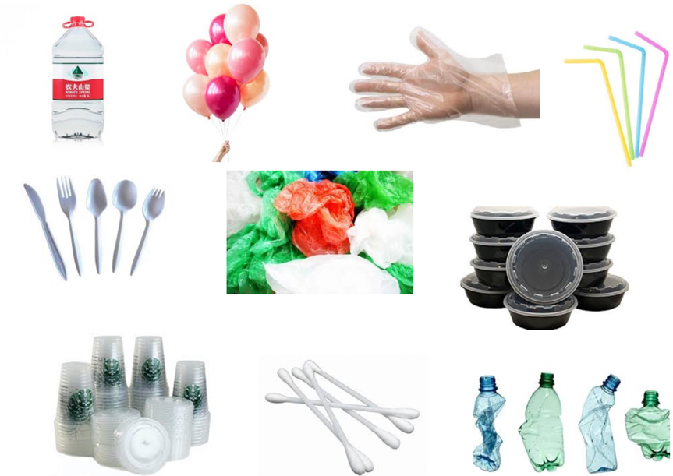A Plastic Ocean is a new documentary that looks at the problems that are caused when plastic waste goes into the sea.

1. 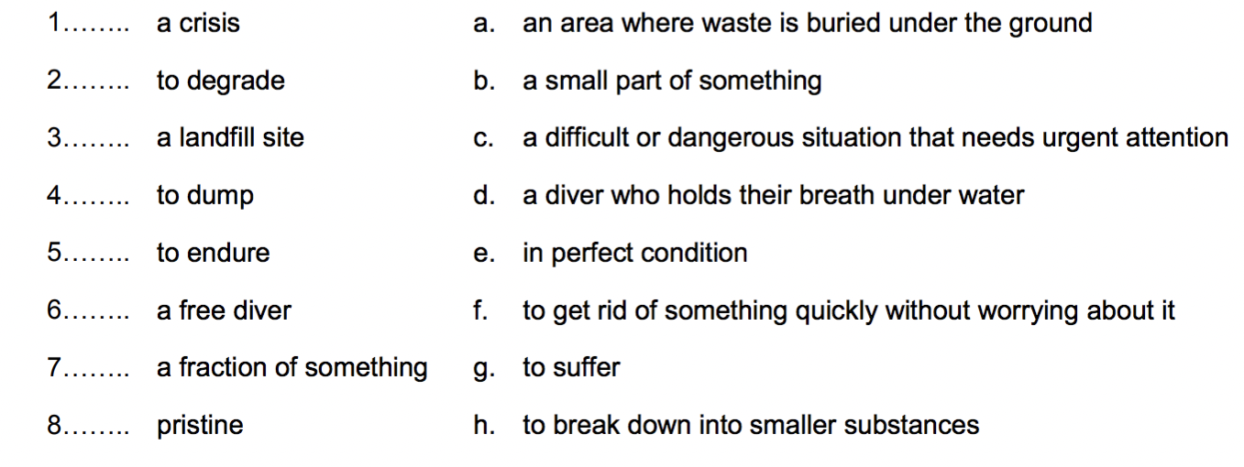**Preparation:** Match the vocabulary with the correct definition and write a–h next to the numbers 1–8.

2. **Check your understanding**: multiple choice. Choose the best answer to these questions.  
1. When did the first narrator start following blue whales?

a. When he was a teenager

b. When he was a child  
c. When he was an adult

2. How many tons of plastic are dumped into the oceans every year?

a. Eight million

b. Five million

c. Nine million

3. How does the *free diver* feel about her work helping to clean the oceans?

a. That more people should do it

b. That it’s her way to pay back the ocean for all the pleasure it has given her

c. That it’s an impossible job

4. Why is the plastic in the ocean never going to *degrade*?

a. Because it has nowhere to go  
b. Because there is too much of it  
c. Because more and more is being dumped daily

5. What has been built on the landfill sites?  
a. Beaches – including hotels for tourists  
b. Factories – including plastic bottle factories  
c. Communities – including their food production

6. What does the main narrator believe is possible?  
a. He believes change is possible and it starts with us.  
b. He believes change is possible if we stop buying plastic bottles.  
c. He believes change is possible if we stop throwing bottles in the ocean.

3. **Practise listening:** Listen to the video and fill in the gaps.

|  |  |
| --- | --- |
| Narrator:  Man on boat: Narrator:  Diver:  Narrator:  Presenter:  Narrator:  Diver:  Narrator:  Man on boat: Narrator:  Diver:  Narrator:  Narrator: | I _____________ the first time I ________ a blue whale.  Look, look! (... Wow!)  I’d _____________ them since _____________. Where do you think it’s from? Is it from a ship? I ___________ see plastic ________________. We __________ in what we ___________ was a relatively pristine _____________. I ____________ to wonder what _______ __________ in oceans elsewhere on the __________.  Growing up, my world was the__________. It’s where I feel the ________ spiritual.  As a free diver, it was a place where I proved myself to myself. Finally, I have the opportunity to pay the sea back. Only a fraction of the plastic that we produce is _____________.  This is _________ __________ _____ degrade. It’s got nowhere to go. It’s something that these animals are forced to endure because it was man-made and we put it into their environment. The record is ___________ pieces of plastic inside one ______ -day- old chick. If the plastics are in the food chain for the dolphin, then they're also in our food chain. Exactly! _________________ are __________ on these landfill sites ... So sweet potatoes, corn, sugar cane, all growing on _________ years of garbage. Do you have anything not ___________ in plastic? ... No! We have to make our life better for our kids' children. Change is possible! It starts with us! |

4: **Practise writing:** Think of how you can use less plastic in your life.

__________________________________________________________________________________________________________________________________________________